

**DONALD R. GREBIEN SANDRA CANO**

MAYOR DIRECTOR OF COMMERCE

**PAWTUCKET BUSINESS DEVELOPMENT CORPORATION**

**PRE-APPLICATION FORM**

**Department of Planning & Redevelopment, 137 Roosevelt Avenue, Pawtucket, RI 02860**

**Instructions:** Applicants shall complete the first three pages of the Pre-Application Form. PBDC staff will review and determine if you are eligible for this PBDC program. Those who are eligible will need to compile the necessary application documents listed in Appendix A if they do not already have them.

1. Name and Address of Business.

|  |
| --- |
| Applicant Name(s):  Business Name:  Address: |

1. About Your Business (Briefly describe your business, owners experience, business history and type of product or service offered, etc. Are you a sole proprietorship?

|  |
| --- |
|  |
|  |
|  |

1. Give a brief statement about the purpose of the loan and the amount.

|  |
| --- |
|  |
|  |
|  |
|  |

1. How will this Loan Benefit the City? Will this loan assist with the retention of or creation of jobs? (increased employment, type of jobs, any training programs or special benefits, employee mobility opportunities and any impact in terms of economic revitalization to the area)

|  |
| --- |
|  |
|  |
|  |

5. Have you applied for or are in the process of applying for bank loan? (Yes or No) *The required materials for a PBDC loan will match those required for a bank loan with a few additional items listed in Appendix A.*

|  |
| --- |
|  |

Do you currently have a Unique Entity Identifier (UEI) assigned through SAM.Gov? If so, please provide the UEI Number below; if not please write no. **(See Appendix C)**

|  |
| --- |
|  |

(An UEI is not required at the time the initial application is submitted but will be required if the applicant is approved to complete a full loan application)

For more detail about PBDC’s loan programs contact Pawtucket City Hall-Commerce Department at 401-728-0500.

### Certification, Credit Authorization, and Confidentiality of Records

To the best of my knowledge, the above information is accurate, and I (we) understand that any false or misleading information. I (we) provide may lead to my (our) disqualification from this program. I (we) authorize the City of Pawtucket and/or Pawtucket Business Development Corporation to make whatever credit inquiries it deems necessary to verify the accuracy of the information provided in connection with the review of this credit application.

I (we) hereby request that information provided by me (us) and developed by the City of Pawtucket and/or the Pawtucket Business Development Corporation, or its staff or agents, with respect to this application for financial assistance be designated confidential and not open for public inspection, pursuant to 5 M.R.S.A. Section 13119 et sq.

Certain records of the Pawtucket Business Development Corporation are designated CONFIDENTIAL AND WILL NOT BE MADE AVAILABLE FOR PUBLIC INSPECTION. This includes the disclosure of tax or financial information; our assessment of credit worthiness or financial condition; records obtained by the Pawtucket Business Development Corporation in connection with the monitoring or servicing of an existing project; proprietary information; and, information regarding the financial status of the application.

Signature of Applicant: Date:

Title, Company Name (if appropriate) ________________________________

Signature of Co-Applicant: Date:

Title, Company Name (if appropriate) ­________________________________

**Appendix A: Future Supplemental Materials**

**If after review of your application it is determined that your business is eligible to apply for a Loan with the PBDC, the following submittal materials will be required. Most can be obtained from a bank loan application.**

Exhibit 1. A brief (one to two page) description of the business, owners experience, history of the business and type of product or service offered, etc. Include a statement on the expected benefits the company will receive from the loan. Provide a description of the educational, technical and business background of all the people in the management of the company. Copy of Franchise Agreement (if applicable).

Exhibit 2. Copy of your Business Plan.

Exhibit 3. A statement detailing the exact project costs and the sources of funds for the project. Identify the sources of equity to be invested in the project. Describe in detail the use of all the funds involved in the project, i.e. working capital, inventory, equipment, leasehold improvements or other. Provide a list of all machinery and equipment to be purchased with the loan proceeds (please complete schedule 1 on the 2nd page of the application form to satisfy this requirement).

Exhibit 4. A current balance sheet, income statement, cash flow statement and a chart of accounts receivable and accounts payable ageing. Statement should be current to within 90 days. Provide a schedule of current debts including original date and amount, outstanding balance, interest rate, monthly payment, maturity date, security and status.

Exhibit 5. Copies of tax returns for the business for the past three (3) years (if available).

Exhibit 6. A projection of earnings on a quarterly basis for the next two (2) years of operations demonstrating the ability to repay the proposed loan plus all other obligations.

Exhibit 7. List of collateral to be offered as security for the loan (please complete the table under Schedule 2 on the 2nd page of the application to satisfy this requirement).

Exhibit 8. Resumes of owners, principals and key management personal.

Exhibit 9. Provide evidence of legal entity, i.e. DBA certificate, partnership agreement, or articles of incorporation.

Exhibit 10. Personal Financial Statements for all owners with a ten percent (10%) or more ownership interest.

Exhibit 11. Resolution from the Board of Directors authorizing the business to borrow.

Exhibit 12. Copy of existing or proposed lease or proof of property ownership. If owned, a Letter of Good Standing from the Pawtucket Tax Collection Department.

Exhibit 13. A brief statement of need describing why PBDC loan participation is necessary and the project’s potential economic impacts Discuss increased employment, type of jobs, any training programs or special benefits, employee mobility opportunities, etc. (please complete schedule 2 on the 2nd page of the application form to satisfy this requirement).

Exhibit 14. Any marketing information or materials the business currently uses.

Exhibit 15. A Letter of Good Standing from the Rhode Island Division of Taxation (if you are an existing business). [Request for Letter of Good Standing Form](https://tax.ri.gov/sites/g/files/xkgbur541/files/forms/2014/Misc/LOGS_m.pdf)

Exhibit 16. **A Certificate of Good Standing** from the RI Secretary of State (this is required only if the borrower is an existing business organized as a corporation or limited liability company). [Instructions for Requesting a Certificate of Good Standing](https://www.sos.ri.gov/divisions/business-services/order-certificates)

Exhibit 17. If the project involves real estate acquisition or improvement, provide and independent appraisal on an as completed basis by a certified appraiser.

Exhibit 18. Are there any officers of the company have been involved in bankruptcy or insolvency proceedings? If so, provide details. If any officer or the business is involved in any pending lawsuits, provide details. If the officers for your business have not been involved in any such proceedings, affirm with your initials here ______

**Additional Materials Required Prior to a Loan Closing:**

Exhibit 19. A completed IRS W-9 Form.

[W-9 Form Template](https://www.irs.gov/pub/irs-pdf/fw9.pdf)

Exhibit 20. A unique Entity Identifier (UEI) Number from Sam.Gov **(See Appendix C)**.

Exhibit 21. A copy of the business owner’s insurance policy which lists the *Pawtucket Business Development Corporation (PBDC)* as an ‘Additional Insured’ under the policy.

  

Letter of Good Tax Standing Cert. of Good Standing Form W-9

**Appendix 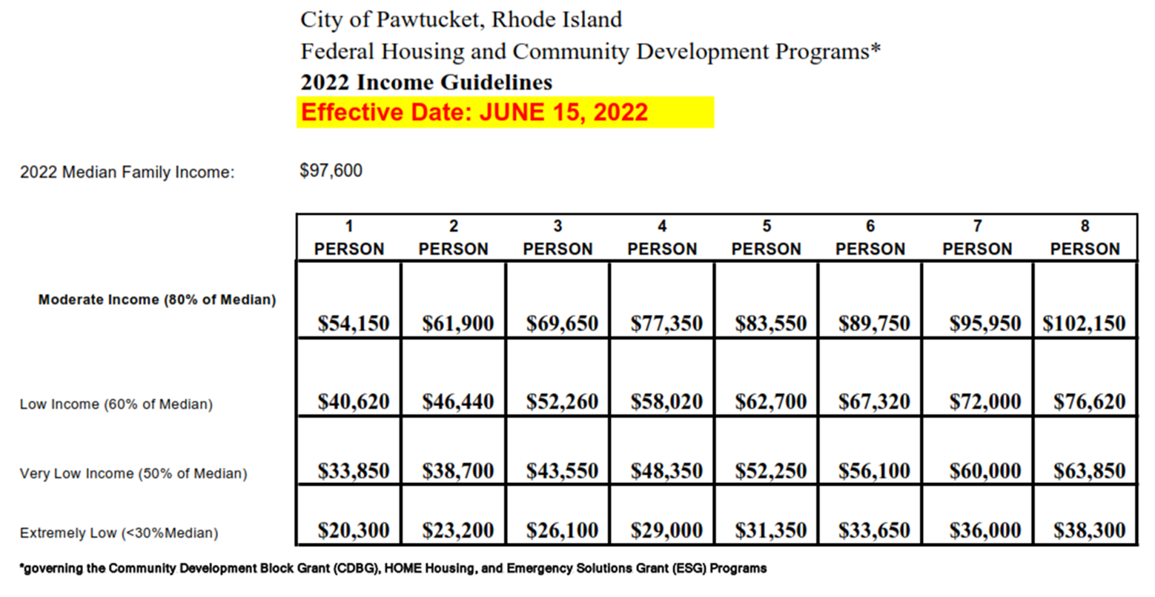B: Income Guidelines for Low/Moderate Income Job Creation Requirements**

**Appendix C: Obtaining a Unique Entity ID (UEI) through SAM.GOV**

In order to be eligible to receive funding through this program and any future funding through the PBDC, a business **must obtain** a Unique Entity ID (UEI) through **SAM.GOV**. This process is free however may take several weeks from start to finish.

**In order to register for Unique Entity ID (UEI), please select the link below and follow the instructions:**

**LINK:** [**https://sam.gov/content/entity-registration**](https://sam.gov/content/entity-registration)**. QR:** 

**Additional Guidance for obtaining an Unique Entity ID (UEI):**

* To see comprehensive instructions and checklist for entity registration, follow the link below:

<https://iae-prd-videos.s3.amazonaws.com/pdf/entity-checklist.pdf?X-Amz-Algorithm=AWS4-HMAC-SHA256&X-Amz-Date=20220714T061133Z&X-Amz-SignedHeaders=host&X-Amz-Expires=86399&X-Amz-Credential=AKIAY3LPYEEX3RP4EDU2%2F20220714%2Fus-east-1%2Fs3%2Faws4_request&X-Amz-Signature=2cdf2ebfb2235e9f38a2c670247bb22aa4f89b38588c885345bb832a5960eaa4>

* In order to check your registration status, please follow the link below:

<https://sam.gov/content/status-tracker>

* What do the different registration statuses mean?

<https://www.fsd.gov/gsafsd_sp?id=kb_article_view&sysparm_article=KB0029911&sys_kb_id=ae62cdca1b37c154c5c4dd39bc4bcb0d&sa=1>

* What's the difference between only getting a Unique Entity ID and registering your entity?

<https://www.fsd.gov/gsafsd_sp?id=kb_article_view&sysparm_article=KB0051214&sys_kb_id=dd40f4ef1b9641d0937fa64ce54bcb7a&spa=1>

* What should I do if my entity registration fails the IRS Consent validation?

<https://www.fsd.gov/gsafsd_sp?id=kb_article_view&sysparm_article=KB0016318&sys_kb_id=905be7631ba20d9406b09796bc4bcbdd&spa=1>