City of Pawtucket, Rhode Island

2024-2025
HOME INVESTMENT
PARTNERSHIPS PROGRAM
(HOME)

APPLICATION PACKET

NON-DEVELOPMENT

DUE ON WEDNESDAY, FEBRUARY 21, 2024,
BY 12 P.M.

DEPARTMENT OF PLANNING AND REDEVELOPMENT
137 ROOSEVELT AVENUE, 1st FLOOR
PAWTUCKET, RI 02860

(401) 728-0500, Ext. 430 mgoudreau@pawtucketri.com

City of Pawtucket, Rhode Island
APPLICATION INSTRUCTIONS
HOME Investment Partnerships Program
PY 2024-2025

Please find attached a HOME Program request for proposal application packet from the City of Pawtucket, Rhode Island, for program year 2024-2025. Beginning July 1, 2024, the City of Pawtucket is anticipating $500,000, pending approval from the U.S. Department of Housing and Urban Development. To be considered for funding, all applicants should be mindful of the following:

- The HOME program is a federal program designed to improve the housing stock for all community residents, but principally those residents of low and moderate income.

- Only certain activities are eligible for assistance under the HOME program.

- In addition to basic eligibility criteria, applications will be evaluated as to how well they meet identified 2020-2024 Consolidated Plan, Affordable Housing Strategic component (see attached appendix) and the extent to which they leverage other funding sources or collaborate with the banking community, and/or private funds.
http://www.pawtucketri.com/sites/default/files/uploads/pdfs/Planning/Pawtucket_CP_DPR_1.pdf

- Community Housing Development Organizations (CHDO’s). If your organization is already classified as a City of Pawtucket CHDO, you are eligible for a set-aside of approximately $75,000 that may be allocated through a CHDO. If your organization wishes to apply for CHDO status, please call Mark E. Goudreau at the Department of Planning and Redevelopment.

- All applicants must complete the standard HOME Program application for funding consideration. Applicants should submit TWO (2) copies of the application along with an original signature version {THREE (3) in total}.

- The deadline for applications is WEDNESDAY, FEBRUARY 21, 2024, AT 12 NOON.

- Applications should be hand delivered or sent in care of: Mark E. Goudreau, Community Development Program Manager, Department of Planning and Redevelopment, 137 Roosevelt Avenue, 1st Floor, Pawtucket, RI 02860.

- Applicants who require assistance in completing the application, are unsure about a project’s eligibility or have any other questions, should contact Mark E. Goudreau at the Department of Planning and Redevelopment at (401) 728-0500,
Ext. 430. You may also email questions to mgoudreau@pawtucketri.com For Development Applications, please call or email.

City of Pawtucket, Rhode Island

HOME Program
Funding Application for Non-Development Funding

Due: WEDNESDAY, FEBRUARY 21, 2024, AT 12 NOON

Project Address: _________________________________________________

Name of Organization:_____________________________________________

Contact Person/Title: ______________________________________________

Contact EMAIL:_______________________________________________________

Address: ________________________________________________________

City _____________________ State ______ Zip _____ Census Tract ______

UEI #____________________________Tax ID # ______________________

Check One

Nonprofit For Profit Community Housing Development Organization

HOME Funds Requested

As a grant $___________

As a loan $____________

Match amount* $___________

Total other funds $___________

Total Project Cost $___________

I verify that the information in this application is true and correct. I understand that false statements herein are subject to the penalties of Rhode Island Law relating to unsworn falsification to authorities.

Signature: ______________________________ Date: _______________________

Title: __________________________________

If applicable, please attach a resolution of the Board of Directors authorizing submission of this application;

*ALL HOME FUNDS MUST BE MATCHED WITH NON-FEDERAL FUNDS, ON A $.25 TO $1.00 BASIS. PLEASE SEE ATTACHED MATCH GUIDELINES IN TECHNICAL APPENDIX 1.

**All Homeownership activities must be sold within 9 months from the date of completion or the unit must be rented to an income qualified family. The unit cannot stay empty beyond a 9-month period after completion.

Description of the Proposal
(Must be completed by all applicants)

Project Title: ____________________________________________________

Project Address: _________________________________________________

Attach a narrative description of the program proposed for funding. In the general narrative description of the proposal.

1. Describe which of the priorities of the City of Pawtucket’s Consolidated Plan will be addressed by the proposal and how the activity will meet that priority. Consolidated Plan Housing area attached, copies of the complete report are available for review in the offices of the Department of Planning and Redevelopment, 137 Roosevelt Avenue, 1St Floor, Pawtucket, RI 02860 (401) 728-0500, Ext. 430.

The City of Pawtucket, Rhode Island, does not discriminate against persons based on race, color, religion, marital status, sex, national origin, ancestry, age, familial status, disability or any arbitrary basis. If you need special assistance in order to read and understand the information contained herein, please call the City of Pawtucket, Department of Planning and Redevelopment at 728-0500 ext. 430. You may also email questions to mgoudreau@pawtucketri.com
/tmp/in/input.doc
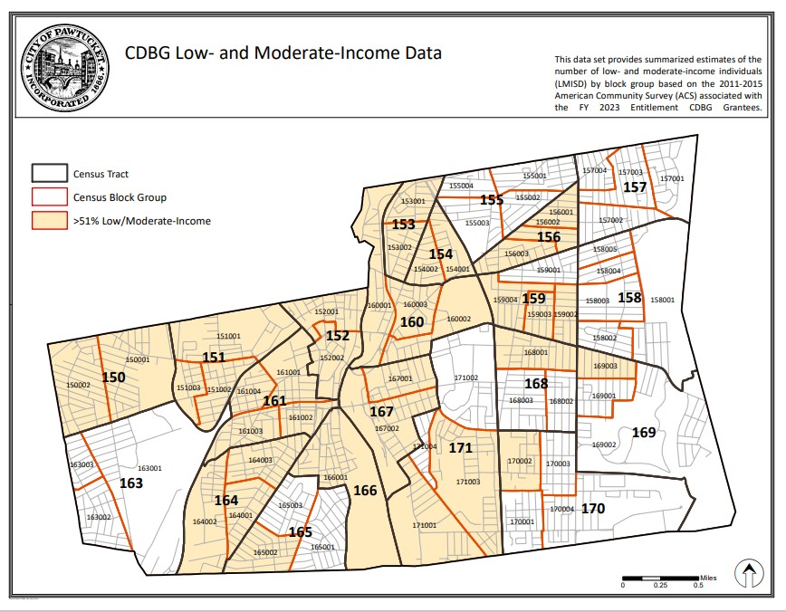
APPENDIX
City of Pawtucket, Rhode Island
2020-2024 Consolidated Plan Strategic Priority Area Summary – Affordable Housing Goals

 |  | Priority
 |  | Funding | Planned Performance
Priority Category | Specific Activity | Ranking | Measure
a. Assist the rehabilitation of | Provide funding pool for nonprofits | High | # of 30-year affordability
foreclosed and other distressed | to acquire and rehabilitate foreclosed |  | units produced
properties for reuse as deed | and other housing for rental housing.
restricted (30 years) affordable
rental housing.
b. Assist low- and moderate-income qualified | Down payment and closing cost assistance | High | # of homebuyers assisted
homebuyers to purchase properties, with | targeted to specific priority purchase areas.
emphasis on multi-families and on the
Woodlawn and Pleasant View neighborhoods.
c. Support small scale (6 space units and | Provide funding pool for nonprofits to acquire | High | # of affordable units produced
under per property) redevelopment of | and rehabilitate distressed properties.
distressed properties with a priority for
permanent supportive housing for
homeless individuals and families.
d. Provide low-cost loan financing to qualified | Provide loan funding pool through the Pawtucket | High | # of housing units rehabilitated
Pawtucket property owners to rehabilitate | Redevelopment Agency for qualified property owners
their properties.
e. Support for tenant-based rental assistance | Providence funding for agencies to administer | Low | # of low/moderate income
programs, with a priority for individuals/ | rental vouchers to low/moderate income households. |  | households assisted.
families with special needs.
f. Provision of emergency rental assistance | Provide one-time emergency stipend | High | # of low/moderate income
to low/moderate income households facing | to low/moderate income households |  | households assisted.
eviction. | facing eviction.
g. Support for appropriately scaled  neighborhood | Provide funding and/or property for | High | # of affordable
infill affordable housing with a priority for | nonprofits to build infill housing to create/preserve |  | units produced.
owner occupancy to create/preserve | affordable rental units.
h. Promote understanding of and access to | Support efforts to promote fair housing | Medium | # of fair housing contacts
the protections of the federal fair housing  law. | awareness to local citizenry.

/tmp/in/input.doc

